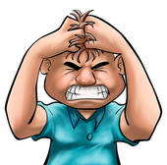

Dealing with anger

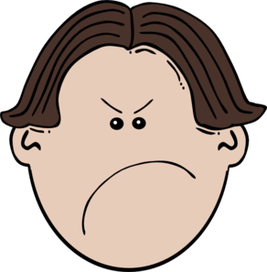

Sometimes things happen that I don’t like

This can make me feel mad.

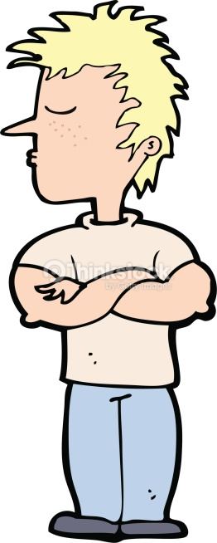

Sometimes my teachers ask me to do things that I don’t want to do. This can make me upset.

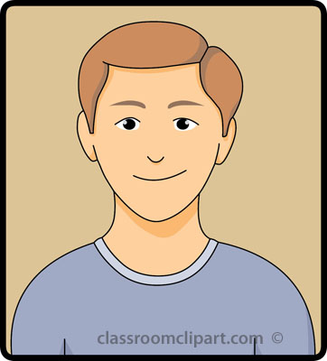

It’s ok to feel mad or upset.

Everyone feels mad sometimes.

C:\Users\Nicole\AppData\Local\Microsoft\Windows\Temporary Internet Files\Content.IE5\9NZI98TU\MC900361044[1].wmf

When I feel mad sometimes I make bad choices in school.

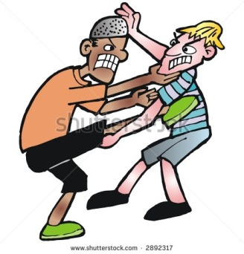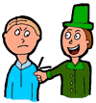 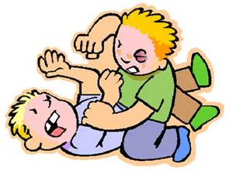

I have hit, pinched, and scratched kids in school when I was mad. Hurting others is a bad choice.

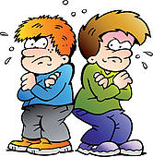

If I hurt other kids they will be mad at me. They won’t want to play with me.

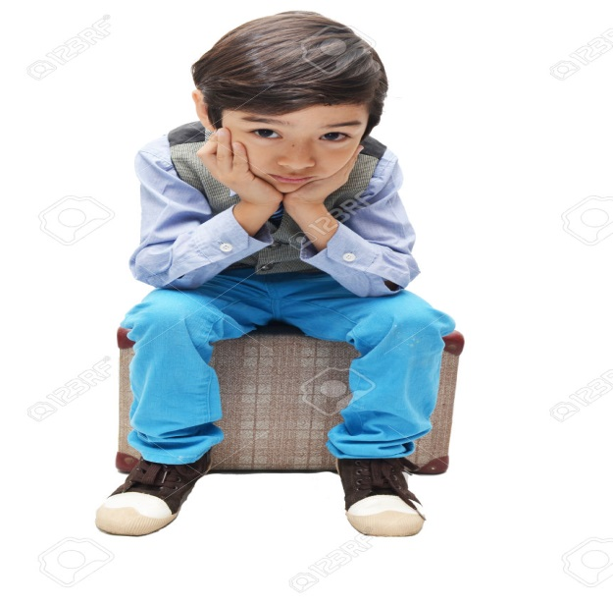

If I hurt others I will sit down for my recess time.

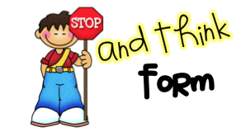

If another kid makes me mad I can tell them to “please stop”. Saying “please stop” is a good choice.

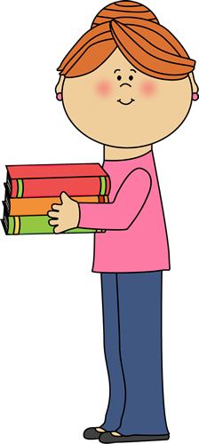

I can ask a teacher for help.

Asking for help is a good choice.

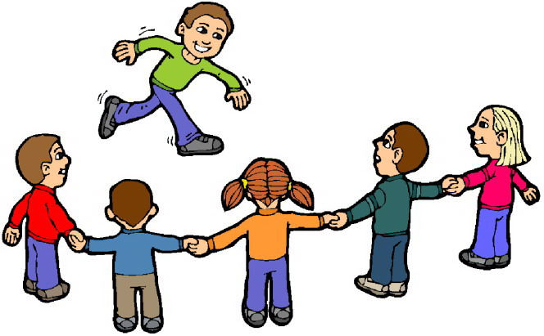

If I’m at recess, I can find another kid to play with.

Playing with someone else is a good choice.

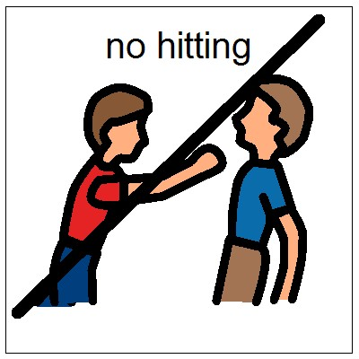

I will not hurt my friends at school. I will keep my hands to myself. Keeping my hands to myself is a good choice.