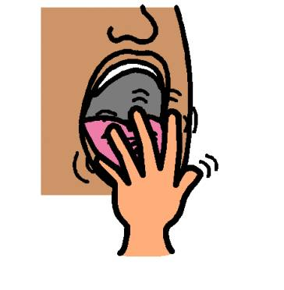

My Mouth

Integration Specialist – Tania Kraus

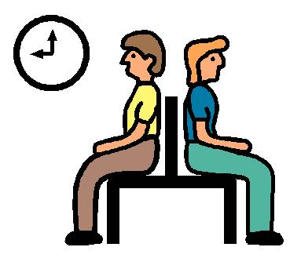

Everyone has to sit and wait sometimes.
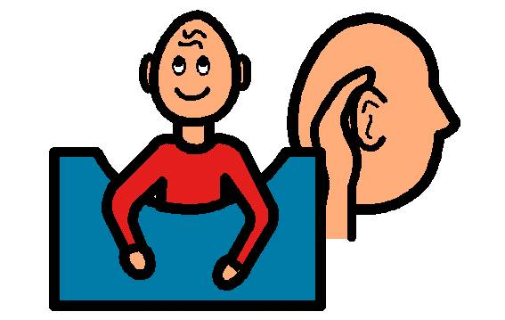

Everyone has to sit and listen sometimes.
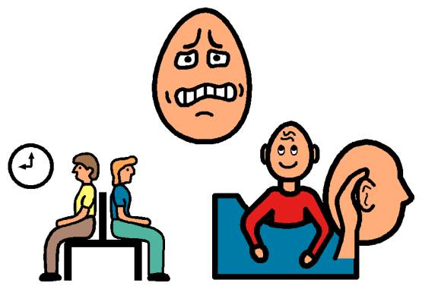

It is hard when I have to sit and listen or wait.
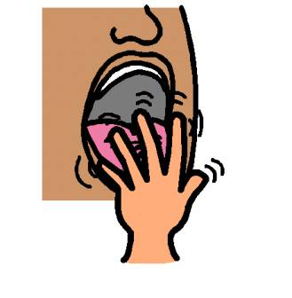

Sometimes when I have to sit, I like to put my fingers in my mouth.
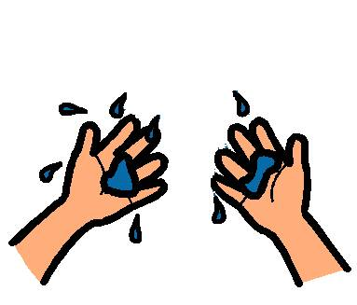

If I put my fingers in my mouth, my fingers get all wet and then it is hard to do my work in school.
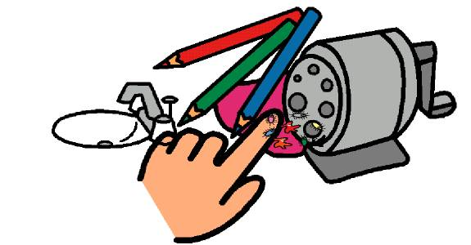

I touch many things. My hands and fingers get germs on them.

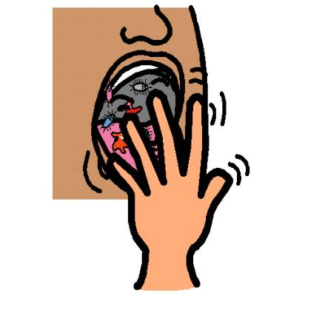

If I put my fingers in my mouth, I am putting germs in my body.
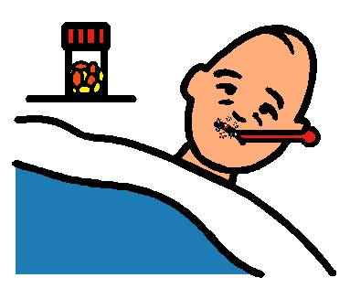

Some germs can make me sick.
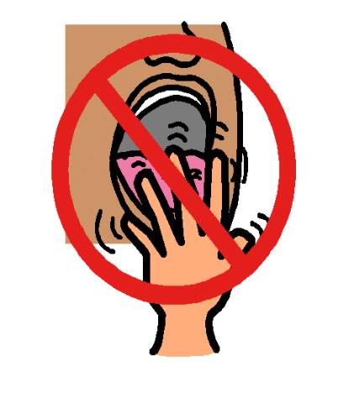

I will try not to stick my fingers in my mouth.
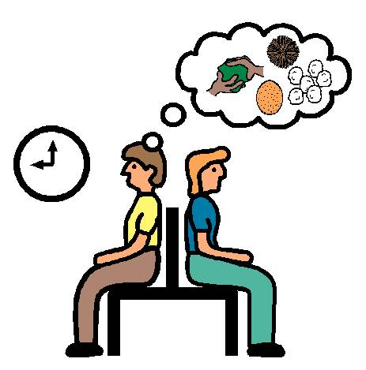

When I have to sit and wait or listen, I will try to think of something else to do with my hands.
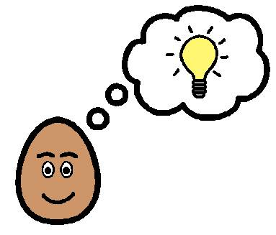

I have some ideas of what else I can do with my hands.
- I can squeeze a ball
- I can work for play-doh time
- I can draw a picture

