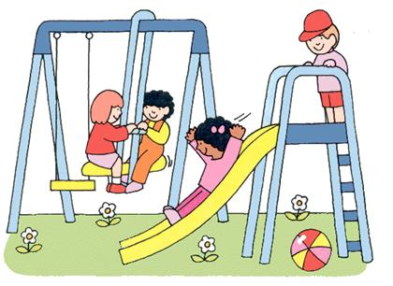
Recess is a fun time. I can play with my friends at
recess.

At recess I can make good choices or bad choices.

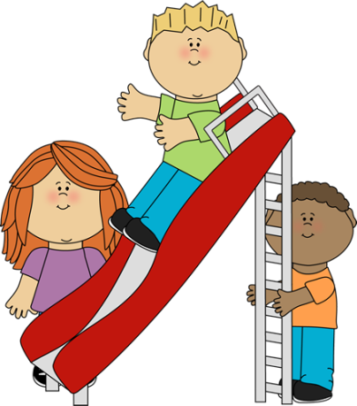
I can go on the play structure at recess.
That is a good choice

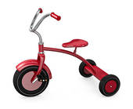
I can ride bikes carefully. That is a good choice.

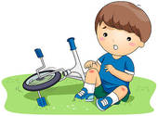
Riding bikes too fast or hitting people with the bike is a bad choice.

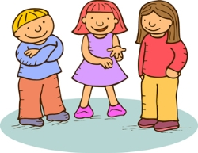

I can talk with my friends.
Using nice words is a good choice.
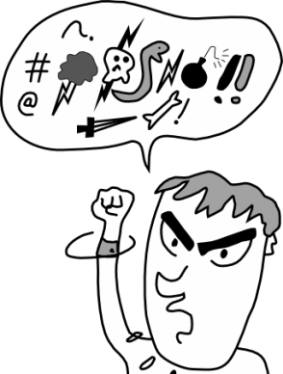
Saying mean things hurts people’s feelings.
Saying mean things is a bad choice.

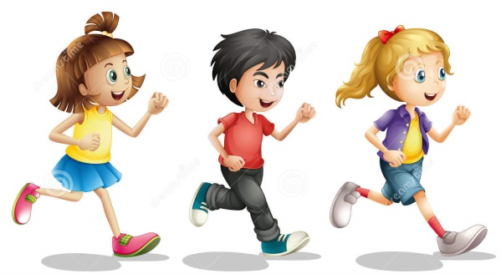
Running around with my friends is fun.
Running with my friends is a good choice.

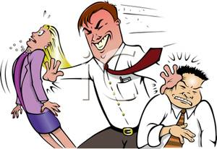
Pushing people or running into people can hurt.
Pushing or running people is a bad choice.
Everyone has their own personal space at recess.
Personal space is like having your own bubble.

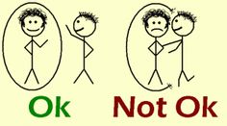
At recess I need to keep my hands to myself so I do not pop someone’s bubble.

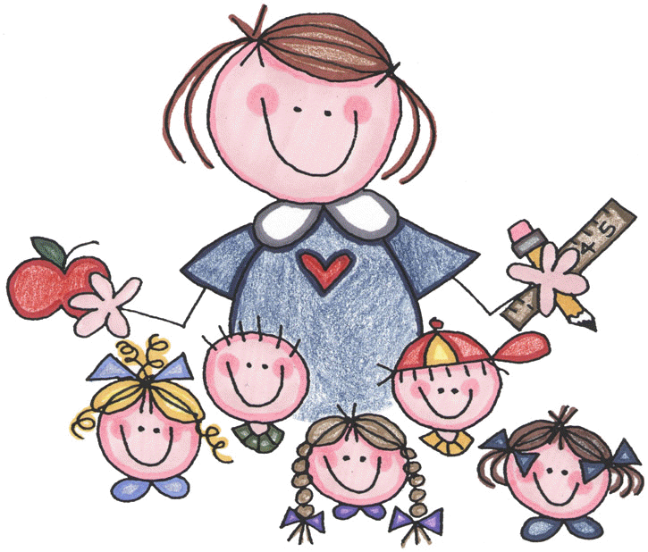
When I make good choices at recess we all feel happy.

