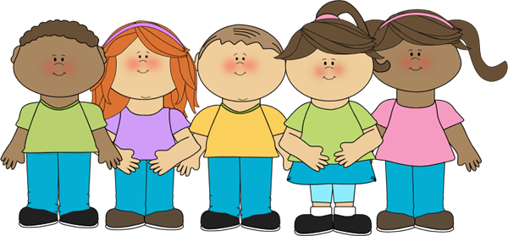

I will not tattle

Sometimes at school other kids annoy me.
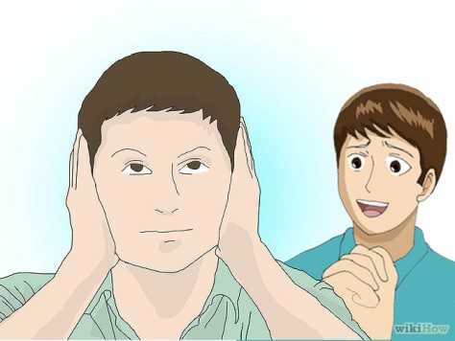
They say things that I don’t want to hear.

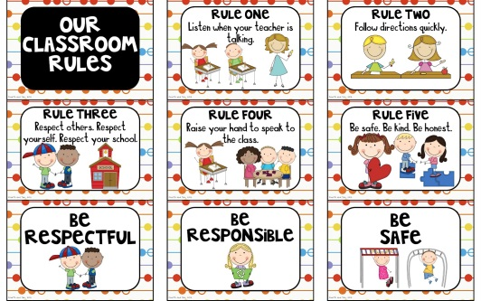
Sometimes they don’t follow the rules.

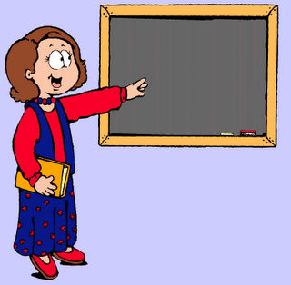
My teacher doesn’t always see when they break the rules or bother me.

I have been telling my teachers what the kids are doing that I don’t like.

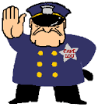
But I am not the tattling police.

Other kids get mad when I tell on them because they can get in trouble.

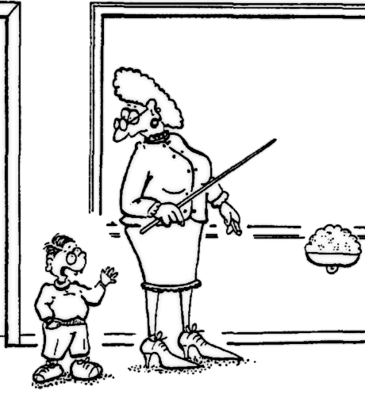
My teachers can’t teach other students when I interrupt them to tattle.

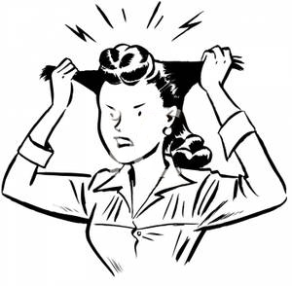
This makes them frustrated.

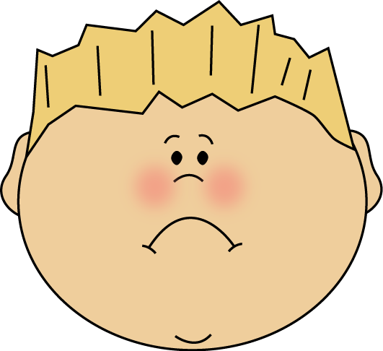
It makes me feel sad that my friends and teachers are frustrated or mad.

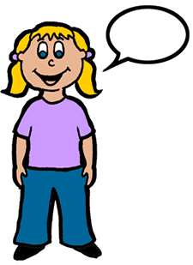
Sometimes it is ok to tell a teacher when something happens so they can fix it.

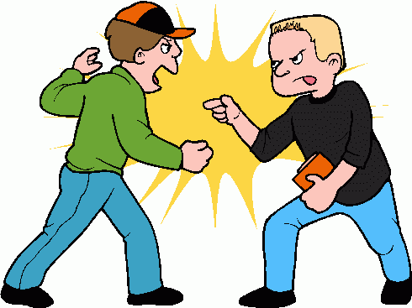
If kids are fighting, I can tell a teacher.

If someone gets hurt, I can tell a teacher.

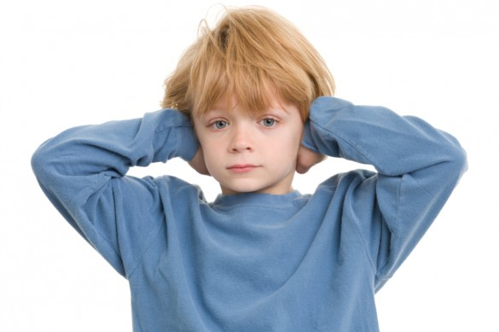
If students are not listening, my teachers will handle it.
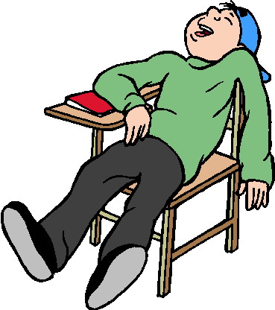
If students are not sitting properly, my teachers will handle it.

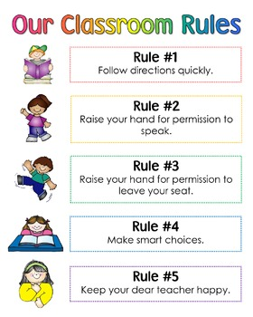
My teachers will make sure that the kids in school are following the rules. Sometimes teachers don’t talk to kids about breaking the rules on purpose. That is the teacher’s choice if they want to stop another kid from breaking the rules.

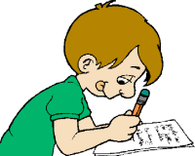
If something really bothers me that another student did, I can write it down and show my parents at home.

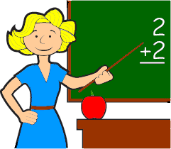
If I don’t interrupt to tattle, my teacher can teach and she will be happy.

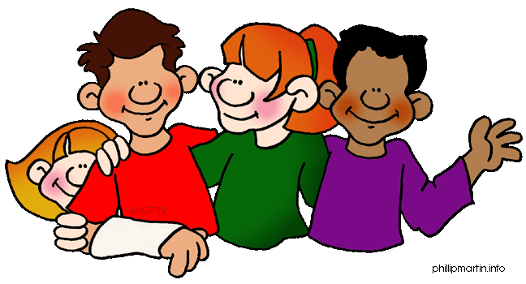
If I don’t tattle, my friends will be happy.

When I make good choices not to tattle I will be happy too.

